# **Designing and Documentation of an Audio Amplifier**

## Parameters for Audio Amplifier

To design an audio amplifier that can amplify audio signals from smartphones or computers with good fidelity, we'll focus on achieving low distortion and maintaining a high signal-to-noise ratio.

Load Impedance: The most common speaker impedance for consumer audio systems is 8 ohms. We can base our design on this value unless you have a specific impedance requirement.

Voltage Gain: A typical voltage gain for audio amplifiers is around 20-30 dB (10x to 30x amplification). This level of gain is sufficient to amplify audio signals from smartphones or computers to a reasonable listening level.

Power Supply Voltage: A suitable power supply voltage for this application would be around ±12V to ±24V. This range provides sufficient headroom for amplification without risking distortion or clipping.

Transistor Selection: For this application, we can consider using bipolar junction transistors (BJTs) or MOSFETs. High-quality, audio-grade transistors such as those from manufacturers like ON Semiconductor, STMicroelectronics, or Toshiba are commonly used in audio amplifier designs. Specific transistor recommendations depend on the desired power output and other design considerations.

**Circuit that has been designed:**

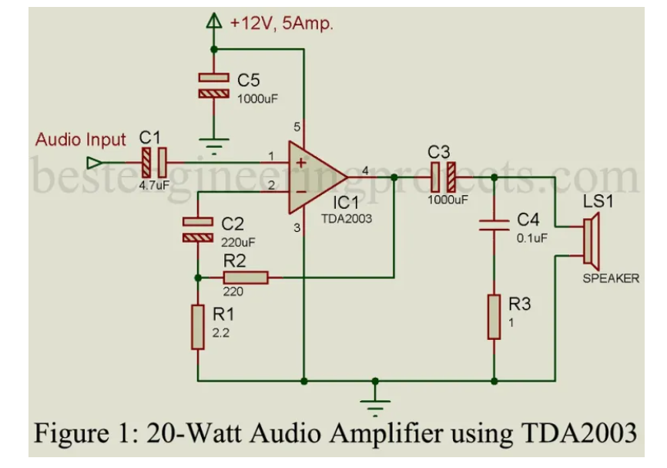

# **Properties of TDA2003 (OP-Amp)**

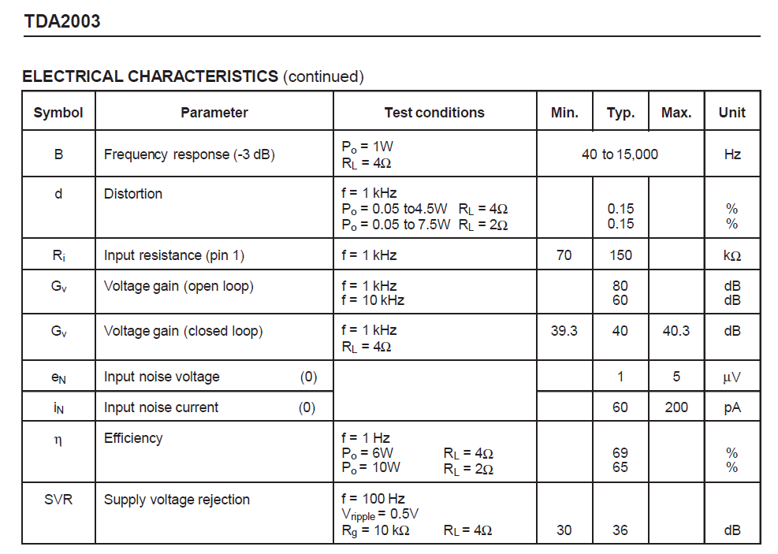

A Perfect Voltage Amplifier Needs four properties,

1. Infinite Input Impedance
2. Infinite Bandwidth
3. Zero Output Impedance
4. Infinite CMRR

Operational amplifier does not give all these properties, but it has comparatively better of all these properties than the bi-polar junction transistor.